## Kansas Association of School Psychologists, www.kasp.org

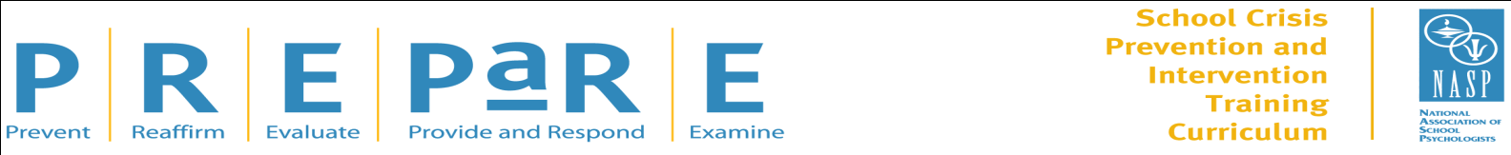

The PREPaRE curriculum has been developed by the National Association of School Psychologists (NASP) as part of NASP’s long-term leadership in supporting and developing school crisis prevention and response capabilities at the local level. PREPaRE is the only comprehensive curriculum developed by school-based professionals with firsthand experience and formal training. The curriculum builds on existing personnel, resources, and programs; provides for sustainability; and can be adapted to individual school needs and size.

**PREPaRE Workshop #2:** Crisis Intervention and Recovery:

The Roles of School-Based Mental Health Professionals **(2nd Edition)**

This 2-day workshop provides school-based mental health professionals and other school crisis intervention team members with the knowledge necessary to meet the mental health needs of students and staff following a school-associated crisis event. With updated research and crisis intervention strategies, this workshop teaches participants how to prevent and prepare for psychological trauma, helps to reaffirm both the physical health of members of the school community and students’ perceptions that they are safe and secure, evaluates the degree of psychological trauma, responds to the psychological needs of members of the school community, and examines the effectiveness of school crisis intervention and recovery efforts. This workshop is an excellent course for all mental health professionals in your district who provide mental health crisis intervention services.

**Presented by:**

Julie Zollinger, EdS, NCSP, School Psychologist, Hays West Central Kansas Special Education Coop

Josh Tanguay, LCP, Instructor, Department of Psychology, Fort Hays State University

Theresa M. Clark, LPC, SB-RPT, NCC, School Counselor, Thomas More Prep-Marian & Holy Family Elementary

***Date: Wed. June 26th and Thurs. June 27th, 2019***

***Time: 8:30-4:30,check in will begin at 8 am each day, please arrive such that you may set yourself up for the day as the workshop will begin promptly at 8:30***

***Location: Great Bend Front Door Classrooms, 1615 10th St, Great Bend, KS 67530***

**Workshop Schedule:**

8 a.m.—Registration

8:30 a.m.–4:30 p.m./Workshop (lunch on your own)

**Fee: $150 per person**

*13 NASP Approved CPD are offered. Certificate of Attendance distributed at end of training*

**Registration:**

To register please go to [www.kasp.org](http://www.kasp.org), registration closes June 10, 2019

.

***Cancellation Policy:*** Partial refunds will be offered until May 31, 2019. After that date, no refunds will be issued, unless the event is cancelled by the organizers, due to inadequate participation, at which time full refunds will be offered. All cancellations and changes must be submitted in writing to Keely Persinger, keely.persinger@gmail.com.

***Accommodations for Individuals with Special Needs:***Please contact Keely Persinger, keely.persinger@gmail.com at least two weeks before the training if special accommodations are needed.

***Questions or Comments:*** If you have any additional questions or comments, please contact Keely Persinger, [keely.persinger@gmail.com](mailto:keely.persinger@gmail.com).